**Information for Volunteers at Makybe Rise Primary School **

At Makybe Rise Primary School, we believe that it is the adults in our community who, together, make the difference to our children’s learning. Involvement in school by parents/carers and other volunteers helps our children achieve the best possible learning outcomes. Your time and effort are greatly appreciated by our staff and students.

All volunteer activities should be undertaken within the guidelines provided by the Department of Education.

This information sheet is provided to assist you in understanding how these requirements relate to your role as a volunteer and to provide guidelines for undertaking your activities. If you have any questions, please feel free to contact the Principal.

**Guidelines for** **Parent/Carer and Child Volunteers**

Involvement in school by parents and carers helps our children achieve the best possible learning outcomes. Research shows that when parents are involved with their children’s schooling, it has a positive effect on the child’s performance.

• Parents are welcomed and encouraged to be involved in their child’s education. All parents who work as

volunteers at school will be expected to read and sign the school’s *Conduct and Confidentiality Agreement.*

Volunteers in school are bound by a code of conduct and confidentiality. They will need to ensure all

communications between volunteers and staff, and between volunteers and students, are respectful,

courteous, and fair; and contribute to a workplace that is free of harassment, bullying, or discrimination.

• They will need to respect the confidentiality of staff, students and other parents always. All

parent/carer volunteers are not to discuss any information they obtain at school with anybody, other

than classroom teachers and the Principal or delegate. Any parent/carer not fulfilling these requirements

may be excluded from the volunteer program.

• Child volunteers (e.g. secondary students completing work placement) are expected to read and have their parents, read and sign the school’s *Work Placement Code of Conduct*. This outlines the school’s roles and responsibilities while they are completing their volunteer hours. They work under the direction of their mentor teacher to support the learning programs.

• Those involved in volunteering, are required to sign in and out each time they attend the school site, through the school’s Administration building.

• It is recommended that parent volunteers arrange for alternative care for their pre-school aged child, as they

can often distract from the normal order of the classroom, thus compromising the learning of the

students in the class.

**Working With Children Check Requirements for Parents/ Carers and Child Volunteers**

The Working With Children Check (WWCC) is a compulsory criminal check for many people who work with children in Western Australia. In some circumstances, a parent or carer may require a WWCC to volunteer at school.

Parent/Carer and Child Volunteers

A parent/carer is considered to be volunteering when they are

* helping in a classroom or attending a day excursion.
* presenting an award or speaking at assembly.
* on canteen duty or helping in a uniform shop.
* assisting at a sports carnival or conducting P&C duties.

A parent/carer is **not** considered to be volunteering when they are

* picking up or dropping off their child.
* watching an event like an assembly or sports carnival.
* attending a parent/teacher interview.
* visiting the uniform shop.

A child is considered to be volunteering when they are

* completing an unpaid practicum or work placement as a part of their educational or vocational studies.
* coaching or umpiring sports.
* mentoring students.
* helping in a classroom.

A child is **not** considered to be volunteering when they are

* enrolled at a school and doing unpaid child-related work with other children at the same school.
* watching an event like an assembly or sports carnival.

When does a Parent/Carer need a WWCC?

You need a WWCC when you volunteer for an overnight camp, billet students in your home or provide one-to-one mentoring to a student.

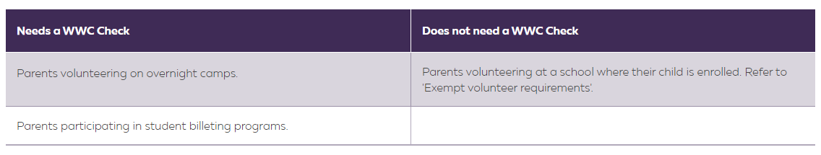

Exempt Volunteer Requirements

From 1 July 2023, a parent or child volunteer will not be able to access the WWCC parent volunteer exemption or child volunteer exemption if they have a current Negative Notice or Interim Negative notice.

To confirm their eligibility to access the exemption all parent volunteers and child volunteers will be required to complete the [Parent and child volunteer declaration form](https://www.education.wa.edu.au/dl/8nr7kdr).

When the volunteer role is not exempt from requiring a WWC Check, for example, when billeting students or volunteering on an overnight camp, you will be asked to complete the Parent and child volunteer declaration form and register your WWC Check details on the form.

This requirement has been introduced in response to amendments to the WWC legislation to help ensure that public schools are safe places for children.

The school will ask parent and child volunteers to complete the form before they can commence any volunteering activities. To understand when you need to complete the form, read the:

* [Checks for parent volunteers in schools fact sheet](https://www.education.wa.edu.au/dl/x0jgnjz)
* [Checks for child volunteers in schools fact sheet](https://www.education.wa.edu.au/dl/l02rdo3).

**Guidelines for Other Volunteers**

• If you do not have a child enrolled at the school and want to do volunteer work you will require a WWCC. The school can advise on the process for this.

• If you are an adult learner, completing volunteer hours as a component of your studies, you are expected to obtain both a WWCC and a Nationally Co-ordinated Criminal History Check (NCCHC). The school can advise on the process for this.

• In accordance with the criminal screening process and Department policy, volunteers should also complete a Confidential Declaration Form (Appendix C) prior to undertaking volunteer work. Where volunteer work is ongoing this form should be completed annually. Under some circumstances the Principal may waive this requirement. This would usually be in the case of special guests invited to the school assembly.

• Volunteers are not generally expected to take responsibility for supervision/personal care of the students

during activities. This is the responsibility of the teaching staff. However, under certain circumstances the

volunteer may be asked to assume full responsibility. If the volunteer accepts this responsibility, they are

required to provide the full duty of care that would be expected of any reasonable adult.

• Activities may only be undertaken without the presence of a staff member if the duty of care is explicitly

accepted by the parent helper/volunteer.

• As you will be conducting your activity with a teacher, it is a good idea to meet with them prior to the

commencement of your specific activity to discuss the scope of the activity, expected outcomes and the

management of any problems encountered whilst conducting the activity.

• Please arrive early so that any last minute changes or issues can be discussed prior to commencement of

the activity.

• Always maintain appropriate conduct, for example suitable clothing, appropriate and respectful language

and no smoking on school premises or during activities conducted as a volunteer.

**Working With Children Check Requirements for Other Volunteers**

When do other volunteers need a WWCC?

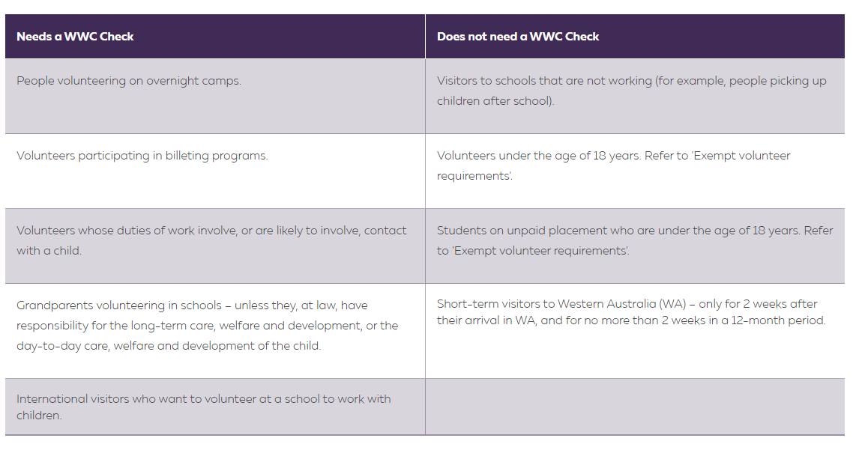

Your co-operation is greatly appreciated, so that we maintain a safe, harmonious and happy learning environment for every member of the Makybe Rise school community.